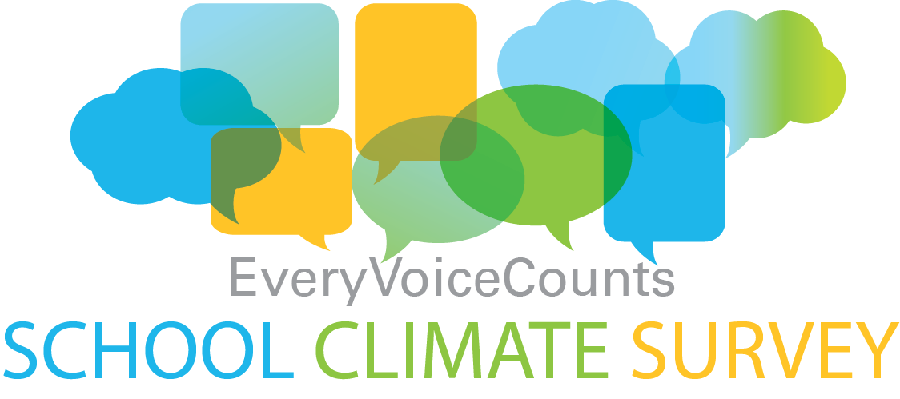
We would like to thank our students, parents, staff and school community for taking part in our school climate survey. By providing us with information that is important to you, particularly in the areas of school safety, inclusive education and mental-health and well-being, you effectively helped guide school planning. Together, you identified what we do well, where we could improve and what your priorities are. Here is how your feedback is making a difference.

The survey questions that we asked:
1. What are your thoughts on your school meeting the educational needs of all of its students?
2. What are your thoughts on your school’s safety?
3. What are your thoughts on how student mental health and well-being is supported in your school?

Top feedback ‘themes’ that we heard are important to you:
- Individual Student Assistance and Class Sizes
- Math Basics
- Playground Equipment and Fencing
- Name Calling, Teasing and Bus Issues
- Mental Health Awareness

Actions taken as a result of your survey feedback:
- Continue to provide straight grade groupings and team teaching in the intermediate grades
- Provide small group teacher help during class time and at recess
- Participate in Board and Ministry of Education’s focus on the Renewed Math Strategy
- Develop further a buddy system between classes for math support
- Communicate that Parent Council has and will continue to fundraise for new playground equipment
- Yard supervisor review resulting in more attention paid to perimeter while on duty
- Work with Sharp bus company to support drivers in managing students
- Educating students and parents regarding coping strategies for stress in school and in newsletter

If you have comments or questions, please contact Principal Rob Santilli by calling 519-426-0820. Please remember to visit www.stjosephsimcoe.ca and follow us @stjcatholic.

