Playnasium
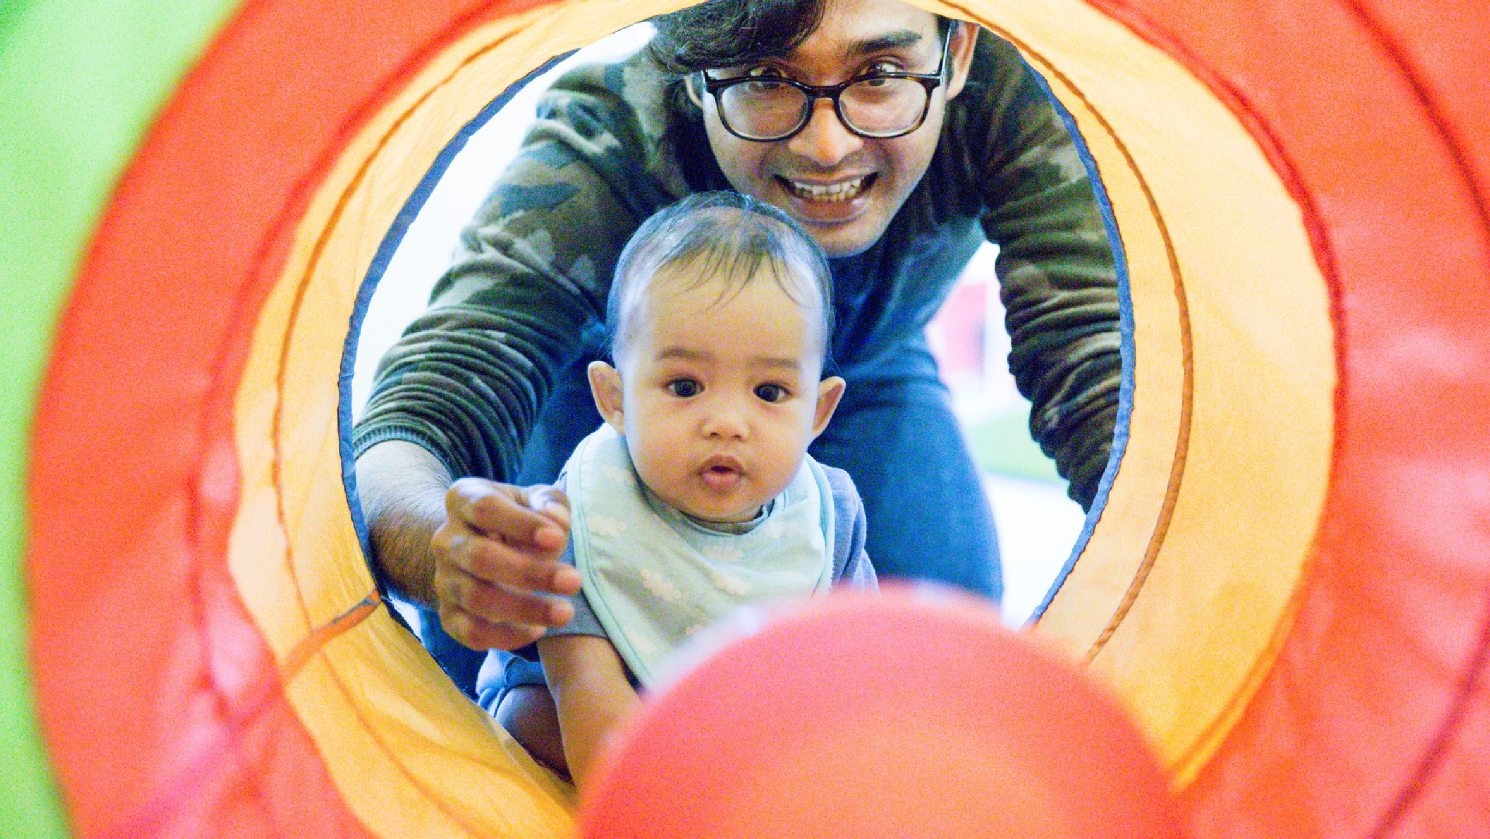
Join us for an open gym opportunity for toddler and pre-school aged children. Little ones will be active to music using a variety of gross motor equipment while developing fundamental movement skills. This is a parented program and children are to be under the supervision of their accompanying caregiver at all times. All those in attendance are asked to wear supportive, indoor and non-slip running shoes and dress comfortably. 10 mos–4 yrs
For more programs like this visit norfolkcounty.ca/parks-and-recreation
Pre-registration is required.
Registration online using the ENCORE registration portal.
Location: Simcoe Rrecreation Centre Cost: $4.00
Dates: Fridays until May 26 inclusive
Time: 9:30-10:30am

