Bring your road hockey stick and play a pickup game of ball hockey with your friends.
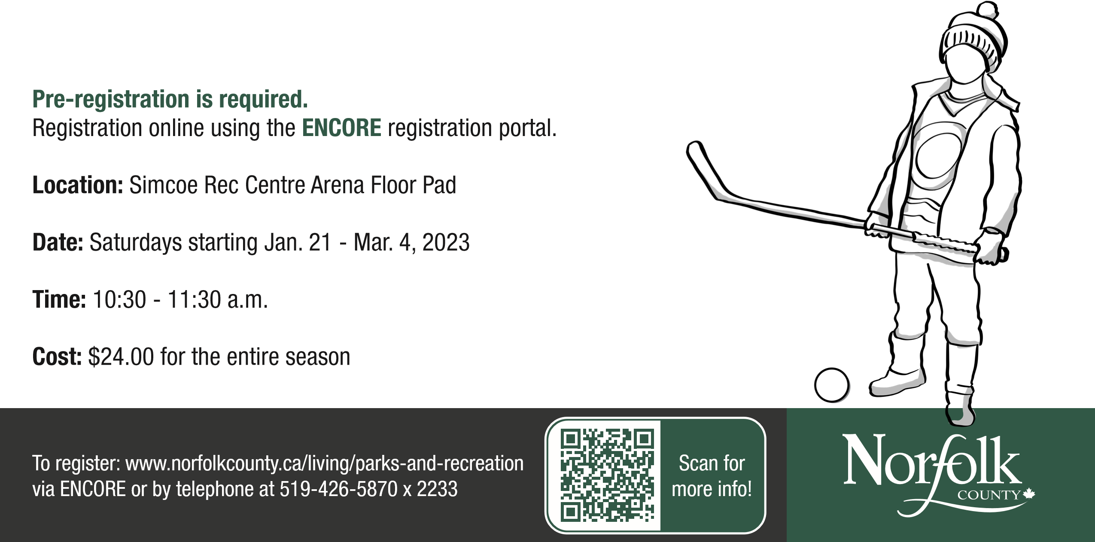
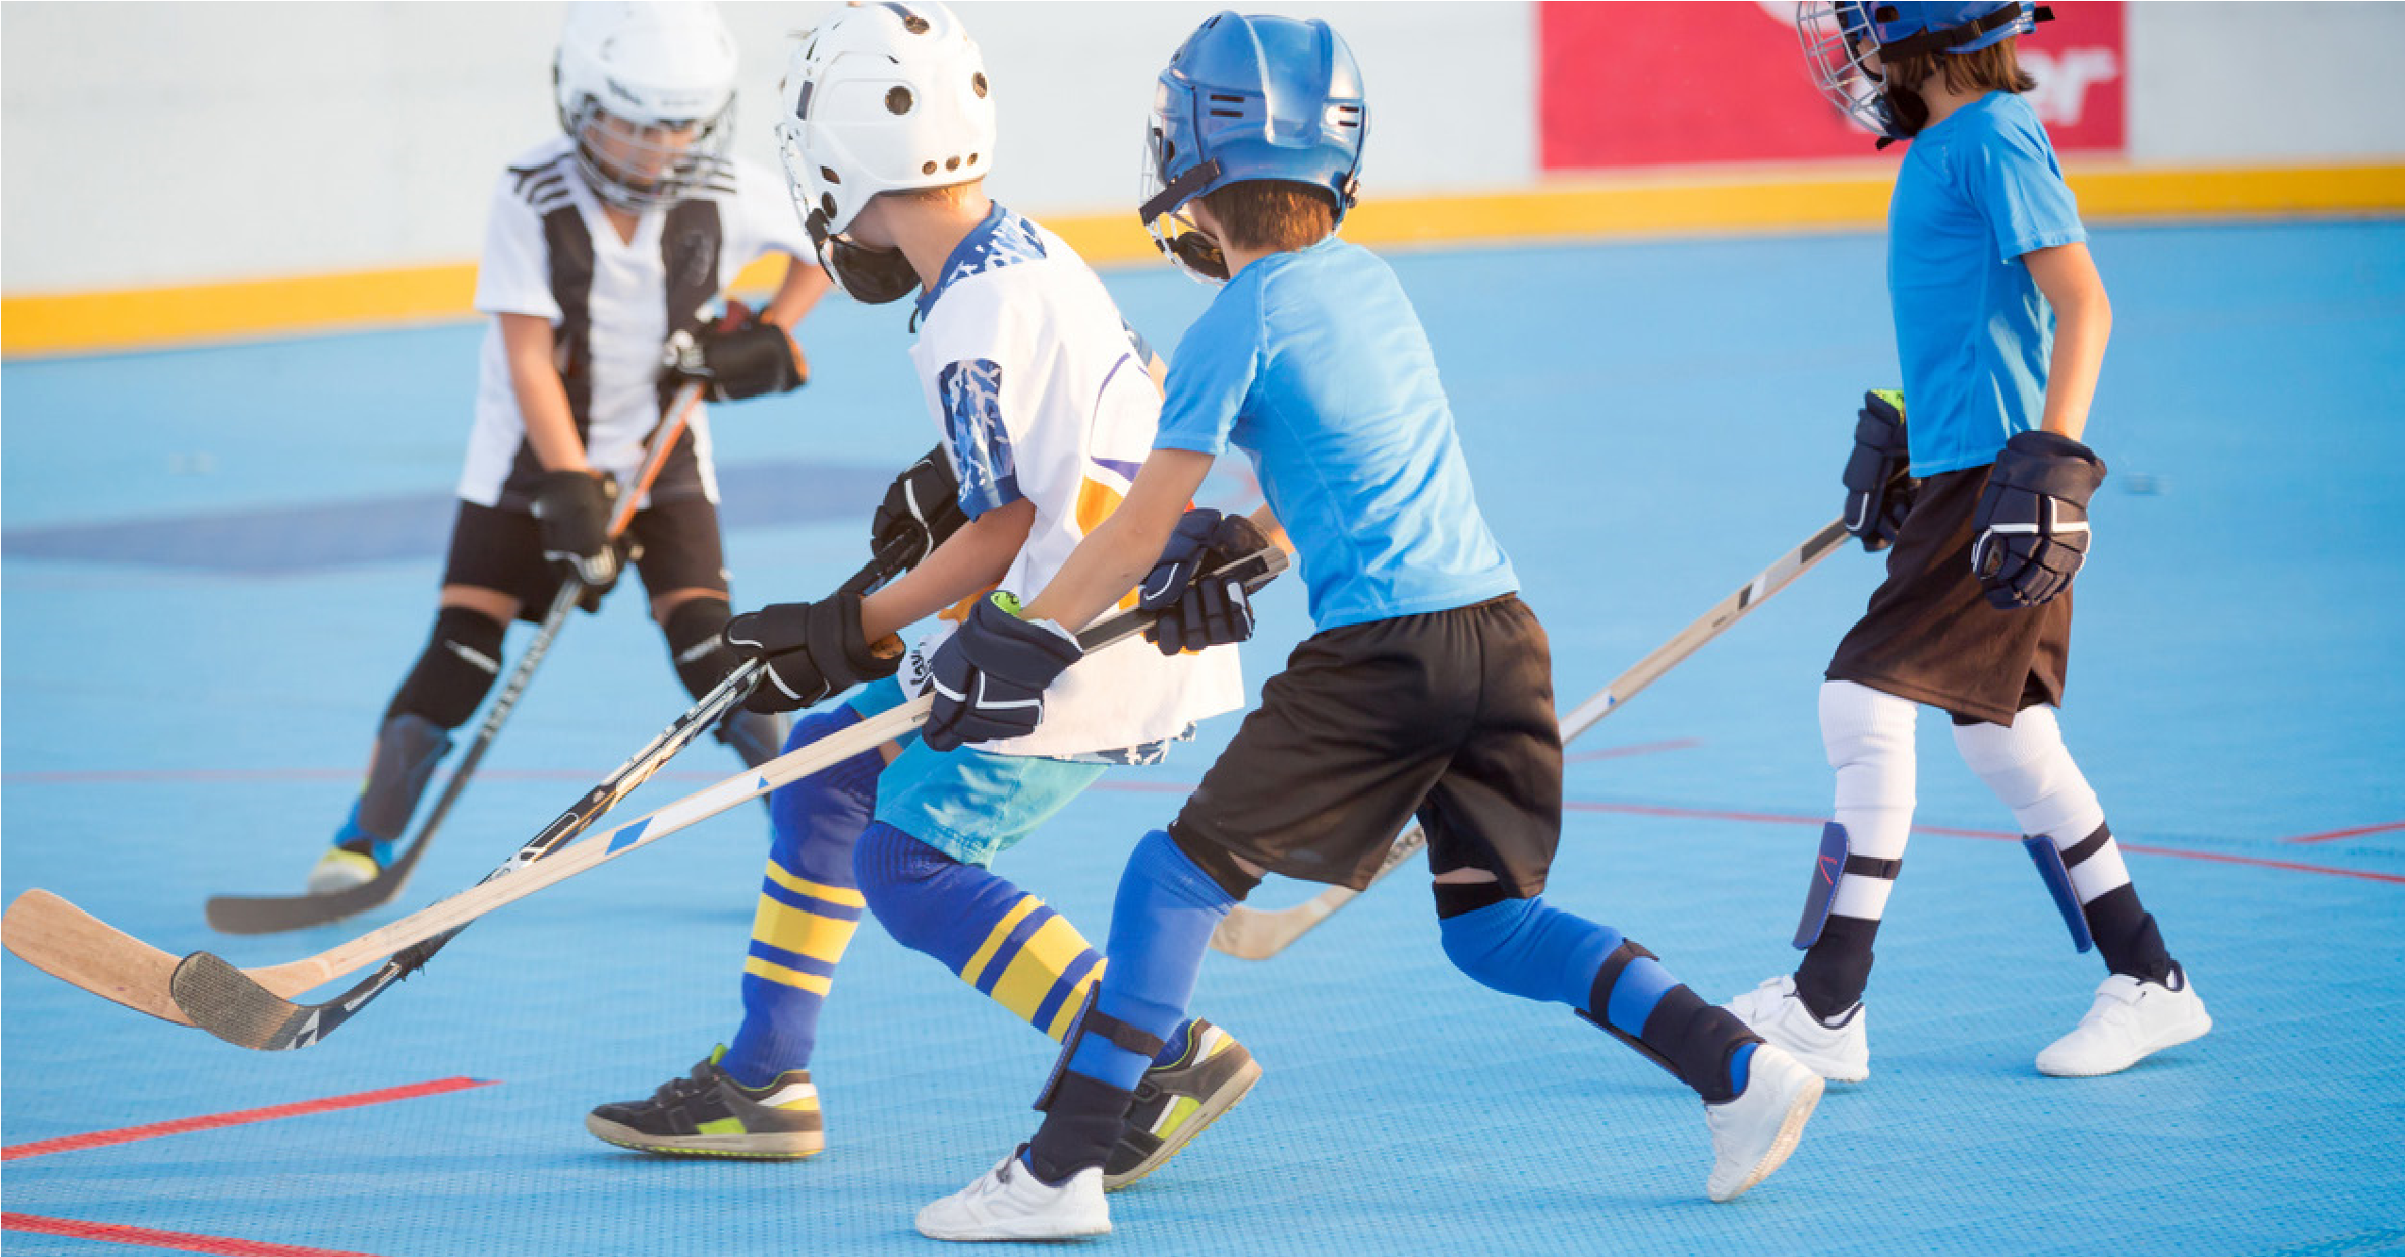
Previous hockey experience not required. Facilitator will start with a few warm-up drills. Participants are required to bring their own equipment; a hockey stick and running shoes are a requirement, all additional equipment/gear recommended. Balls/nets will be provided. Ages 8-12.
Indoor Pick-Up Ball Hockey

