Adaptive Pickleball
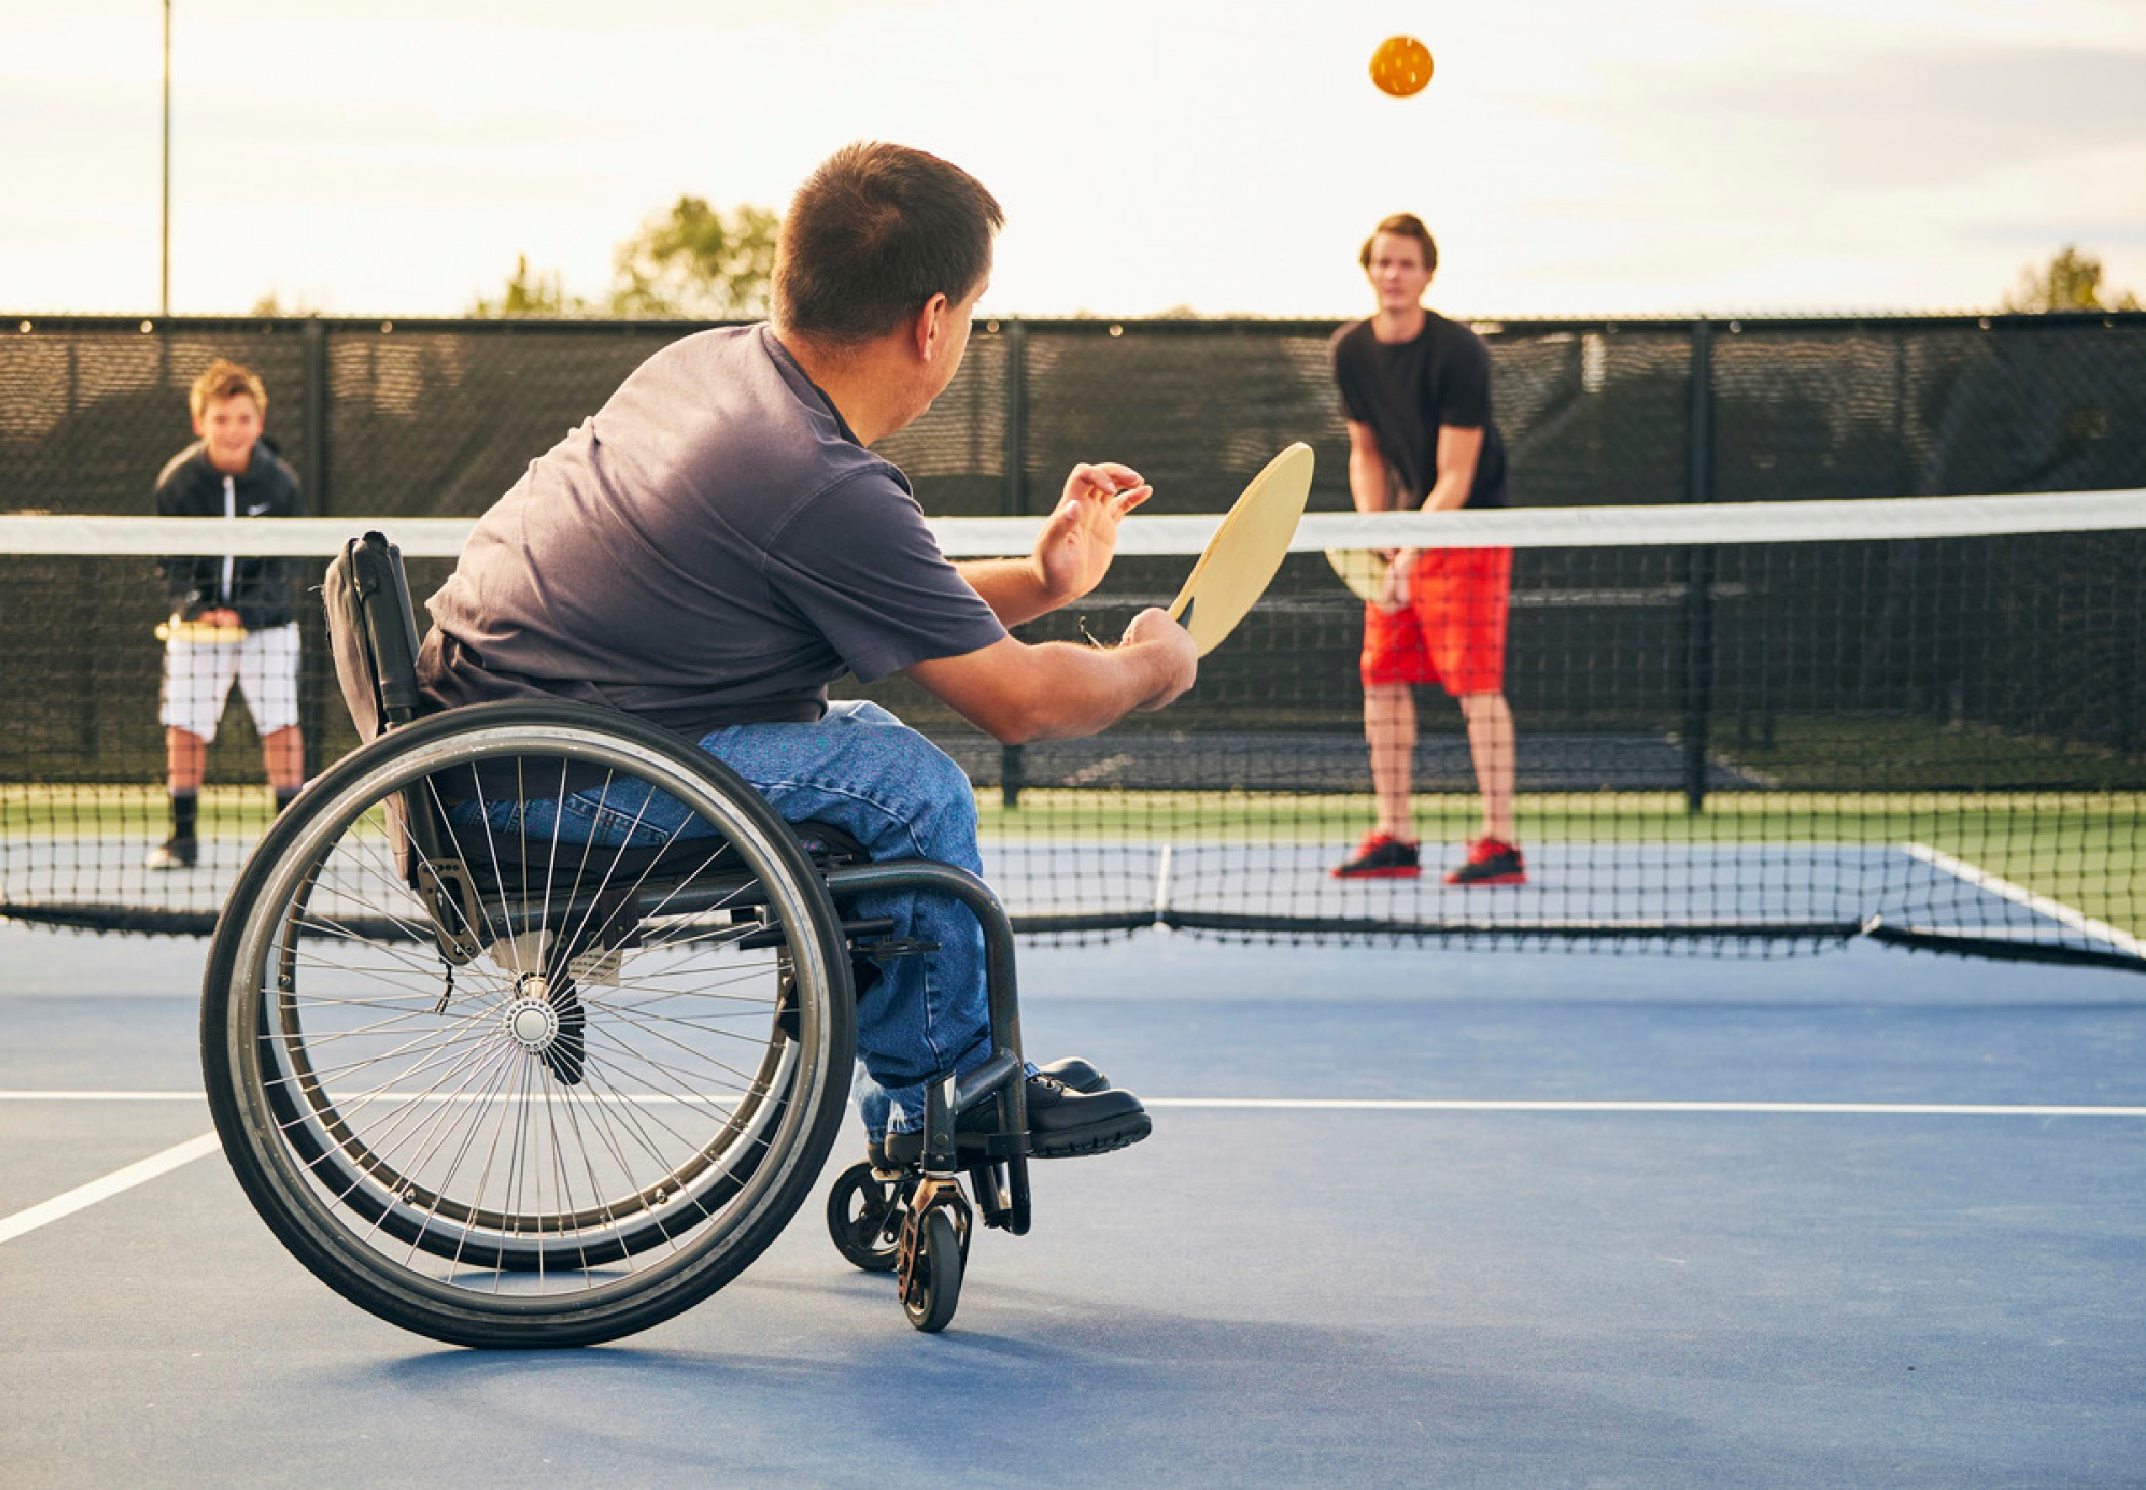
Adaptive Pickleball is an international sport that was designed for people with physical impairments. The game uses equipment and modified rules, including a double bounce, making this sport accessible and fun for all! Participants are welcome to bring their own assistive devices or support person at no additional charge. 18+
For more programs like this visit norfolkcounty.ca/parks-and-recreation
Simcoe Recreation Centre
Tuesdays
October 18 - February 28 10:30 - 11:30 a.m.
$5.00
Exclusion dates: December 20 & 27

